Semester Antara PBO

Nama Kelompok :

-Habibu Riski A11.2020.12807

-Hanna Herwida Oktavia A11.2020.13133

Tugas 2

1. Gambar diagram class

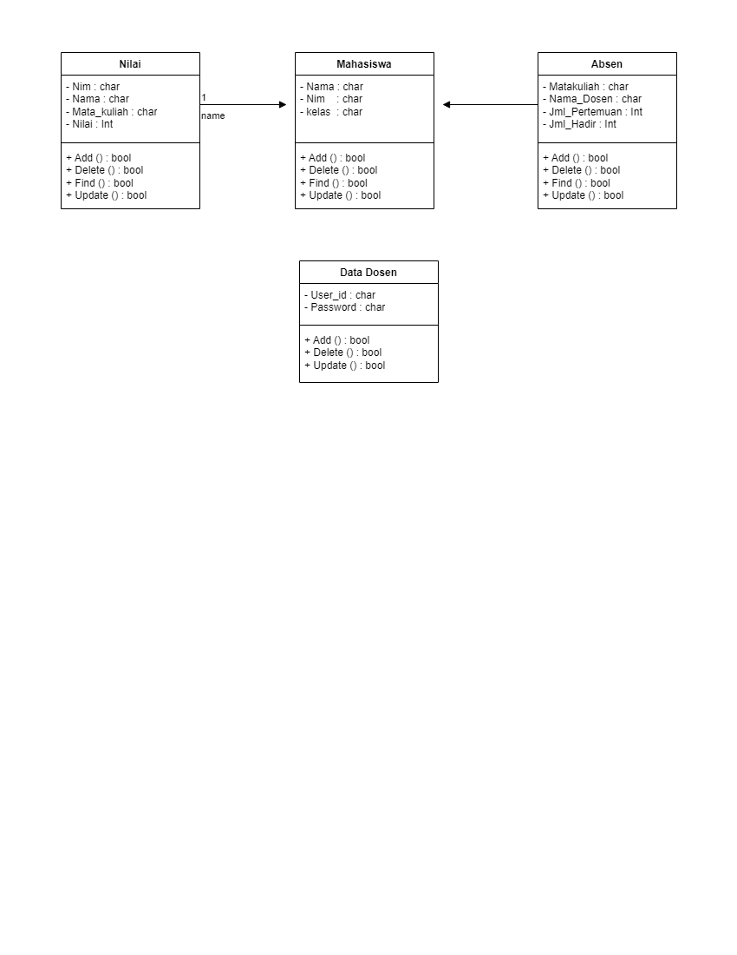

1. Kode Pemrogramman

**package oop.week1;**

**public class Mahasiswa {**

**//atribut**

**String nilai, absen, datadosen;**

**//constructor**

**public mahasiswa(String nilai, String absen, String datadosen ) {**

**this.nilai = nilai;**

**this.absen = absen;**

**this.datadosen = datadosen;**

**}**

**public String getAbsen(){**

**return absen;**

**}**

**public String getNilai(){**

**return nilai;**

**}**

**public String getdatadosen(){**

**return datadosen;**

**}**

**public static void main(String[]args) {**

**Mahasiswa mhs1 =new Mahasiswa("90", "Habiburiski");**

**system.out.println("Nilai : "+mhs1.getNilai());**

**system.out.println("Absen : "+mhs1.getAbsen();)**

**}**

**}**